# Lab 0—Create a Linux Virtual Machine (VM)

# Assignment

Gain some insight into Linux and Operating Systems in general. Read the first 9 slides of this PDF from US Cyber Patriot.  
<https://svgs.instructure.com/courses/495/files/132987?wrap=1>.

# VMware Workstation Player

We will create our VMs using VMware Workstation Player, aka. VMware Player. If you would like to install Player on your own computer for practice or so that you always have your own copy of your lab work, please do! You are not required to use the classroom computers if you have a working version on your own computer.

## Warning about VMware Player on your own laptop

The files for VMs take up a lot of disk space, 2 – 5 GB for Linux and 5 – 10 GB for Windows. Make sure you have 20 GB of free space on your hard disk if you want to create VMs.

Many laptop installations automatically forward your user’s Documents folder to either Google Drive or Microsoft OneDrive. VMware Player stores VM files in your Documents folder by default. **Creating your VM on your cloud drive will use all your bandwidth, fill up your cloud drive, and be unbelievably slow.** So, do not install your VMs on a folder that is redirected to the cloud. If your Documents folder is pointed to the cloud, make a new directory on your hard disk (C:\VirtualMachines, for example) and use that. In the picture below, the Documents folder has been redirected to OneDrive. (Don’t build VMs there!)

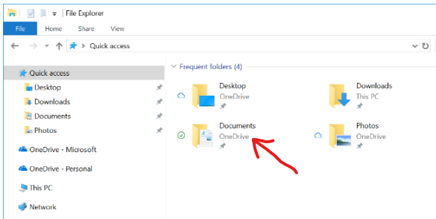

If your Documents folder is redirected to the cloud, or if you aren’t sure, make a new folder and install your VMs there.

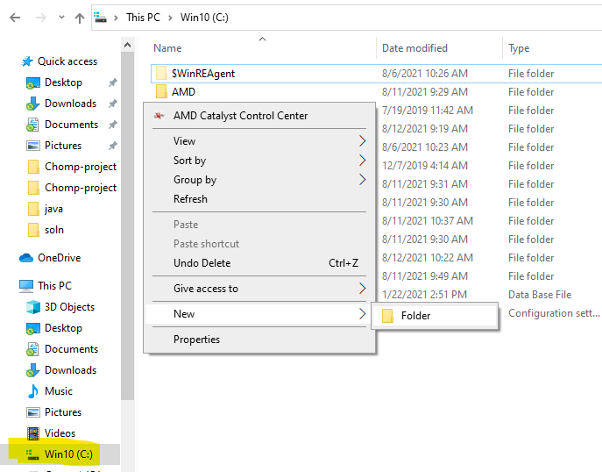

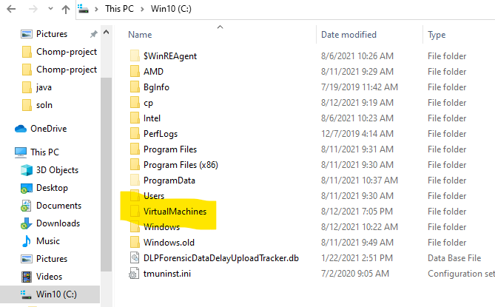

# Linux Versions or Distributions

We will use Ubuntu as our primary Linux platform. We will also install the desktop version of Ubuntu instead of the server version. The server version is similar to what we will use, but it is stripped down (no desktop or apps by default), so it won’t waste disc space or CPU cycles on software that doesn’t apply to its mission as a server. You can do everything in this class from the command line (terminal) in the server version, but many people are more comfortable if they have a desktop.

There are many, many versions of Linux, but most fall into a few families. Redhat Linux is purchased by many professional IT shops. RedHat’s main open source (free) derivatives are Fedora and CentOS (RedHat is ending support for CentOS.) Debian Linux leads another big family, and the most popular derivative of Debian is Ubuntu. Berkeley Software Distribution (BSD) Linux formed the base for Apple’s MacOS. Kali Linux is derived from Ubuntu, and has most common security/attack tools installed.

# Install Ubuntu Linux as a VM

Download the Ubuntu Desktop ISO from <https://ubuntu.com/download/desktop>. If you are in a classroom, the instructor may have you download the ISO from a classroom file share to save Internet bandwidth. As of this writing, the current version is Ubuntu 22.04.3 LTS.

You should have the file ubuntu-20.04-desktop-amd64.iso on your desktop, or some other easily accessible location. Open VMWare Workstation Player. Use the screenshots in the file “Ubuntu-20 Screenshots.docx” as a guide to install the VM. Workstation Player is configured to make many of the choices in Ubuntu installation automatically or by using information you’ve given to Workstation Player. It calls this “Easy Install”. You can learn more by bypassing Easy Install and doing the Ubuntu installation yourself. You can bypass Easy Install by selecting “I will install the operating system later.” (See page 2 of Ubuntu-20 Screenshots.docx. Complete instructions are at the end of the document in the section on page 6 of the document titled, “Note: If you elected not to use Easy Install, or,Installing Ubuntu the hard way.”

**Remember your password when you install your Ubuntu VM! It is possible to recover a VM when you have lost the password, but it is easier to just rebuild the VM again. Remember your password!**

# Apply Updates

Ubuntu will probably try to update itself. Updates are important, so let it update.

# Save a copy of the VM

More robust hypervisors have a feature called “snapshot.” The hypervisor will stop making changes to the main VM files and save all changes to new files instead. Later, if you want to take the VM back to the state it was in when you took the snapshot you simply revert to the snapshot. Workstation Player does not have this feature, so we will do a version of it manually. Shut down your VM. Then copy the folder that contains your VM and paste it somewhere. This requires more disc space than snapshots do, but it will allow you to fall back easily if your original VM is damaged. You may want to put a text file in the new VM’s folder with the username and password you need to use the VM.

# Hand In

What is the command you would use in a terminal window to update your Ubuntu VM? (This will require you to do an Internet search.)